Luther’s Small Catechism

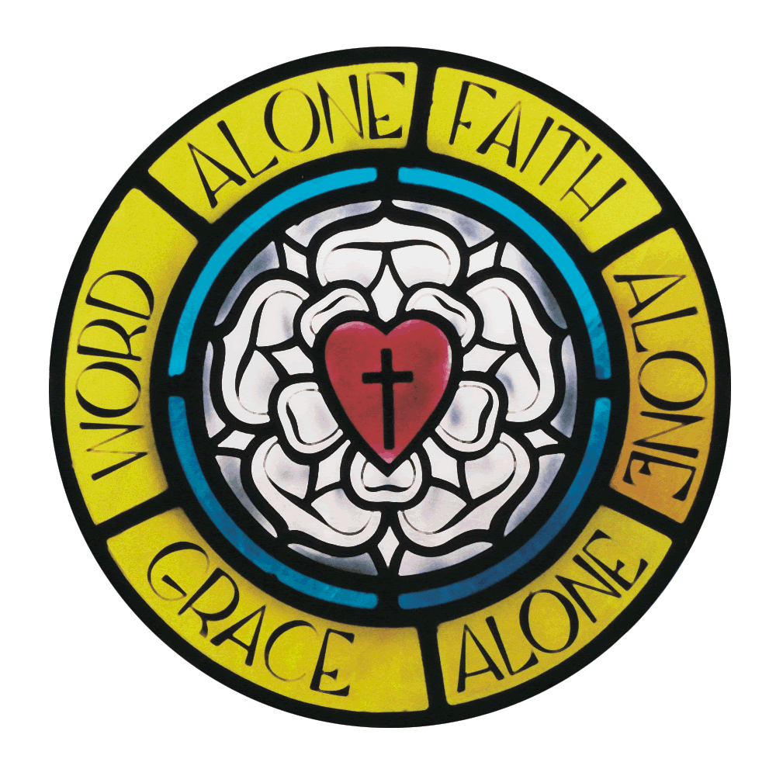

Student Activity Book
“Martin Luther:
An Overview Of His Life”

by

Thomas F. Fischer

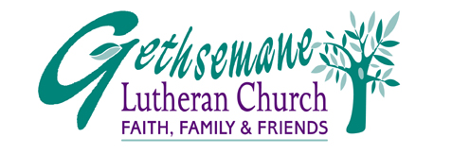
1892 E. Auburn Road
Rochester Hills, MI 48307
(248) 852-5510 GLCRH.org
Martin Luther: An Overview Of His Life
Thomas F. Fischer

Martin Luther was born on November 10, 1483 in Eisleben, Germany. His parents were very strict Roman Catholics and baptized Luther on the day after he was born. This day is called “St. Martin’s Day.”

Though his father was a coal miner, he urged his young son to become a lawyer. However, God led Luther to follow another path. Luther became a priest. There is an interesting story that Luther chose to become a priest during a severe thunderstorm. As lightning crashed close to him, Luther supposedly cried out, “Save me, Lord, and I’ll become a monk.”

When he entered the Augustian order, his father was angry. But Luther and his father did not know God’s plan for Martin Luther. God’s plan was that Luther would change the world.

A Time Of Change

During Luther’s time the world was changing, and changing rapidly. In fact, the what people believed about the world changed almost completely during Luther’s lifetime.

These changes came because of a remarkable number of famous people. These people made remarkable discoveries. These discoveries caused profound changes throughout Europe…and the world.

One of these people was Christopher Columbus. When Columbus discovered America in 1492, Luther was nine years old.

Just a few years later, Gutenberg invented the very first printing press. Until this time the only way to publish or print materials was by copying them by hand. Gutenberg’s invention enabled news, information and all kinds of learning to be shared throughout Europe. During the Reformation, Luther would make extensive use of Gutenberg’s invention. The Ninety-Five Theses, the Large and Small Catechisms were but some of many documents which Luther published using Gutenberg’s invention.

Another famous person who lived during Luther’s lifetime was Michelangelo. This famous artist gained prominence as a great artist and sculptor during Luther’s life. His paintings and views regarding art still influence much of art today.

Leonardo DaVinci, the famous artist, painter and scientist, also did his greatest works during Luther’s lifetime. Nicolas Copernicus, the famous astronomer, also lived during the time of Luther. He was the first to discover that the earth rotated around the sun.

All of these people had at least two things in common. First, they all made remarkable discoveries. Second, their discoveries radically changed the world.

Luther Changes The World

The new ideas which these men taught led to a renewal (or “Renaissance”) in Europe. Throughout Europe there were many new discoveries, ideas and inventions. Luther did not know it at the time. God’s plan for him was to join these great men who changed the world.

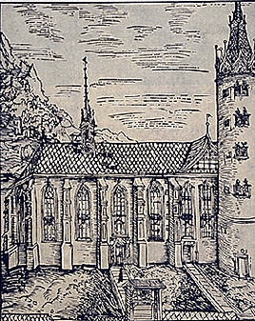Luther’s first step to change the world occurred on October 31, 1517. On that day he nailed ninety-five statements (“theses”) stating that the Pope was wrong. He nailed these Ninety-Five Theses on the front door of the church in Wittenberg.

Everyone who came to church on “Hallow’s Eve” ( “Halloween”) saw Luther’s theses on the door. Since Luther was a professor there, people knew who wrote these theses. News of his theses spread
throughout Germany, to all of Europe, and to the Pope in Rome.
Castle Church at Wittenberg, Germany

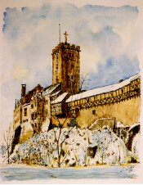
When the Pope found out what Luther had written, he was angry. He called Luther to come to Rome to say he was wrong. Luther refused to do so. It was at this time that Luther spoke his famous words, “Here I stand. So help me, God.”

Since the Pope was the most powerful leader in Europe, even more powerful that Kings, he condemned Luther. He announced that anyone who spotted Luther could kill him. Fortunately, Frederick the Elector (a German Prince), was a friend of Luther. This powerful leader in Germany kidnapped Luther and kept Luther safe in his own castle in Wartburg, Germany.
Wartburg Castle at
Eisenach, Germany

Luther’s Writings And Influence

It was in Frederick’s Castle that Luther made the first German translation of the Bible. He also wrote many things to share the three basic beliefs of the Lutheran Reformation: Only Scripture, Only Grace, Only Faith.

With these three phrases Luther changed Christianity in Europe. Only Scripture meant that Christian faith was based only on the Bible, not the words of a Pope or anyone else. Only Grace meant that eternal salvation is exclusively a gift from God. Only Faith” meant that we can not get to heaven by doing good things. The only way we can get to heaven is by believing in Jesus Christ.

The world which had changed in so many ways during Luther’s life, changed even more dramatically as a result of Luther’s teachings. His teachings changed and reformed the Christian church. What was the result? People learned that they could not buy or earn their way into heaven with money or with good works.
This angered the Pope because he was using this false teaching as a way to raise money for St. Peter’s Cathedral (“Basilica”) in Roman. Luther, however, taught what the Bible said. The only way they could be saved was by Jesus’ dying for their sins on the cross.

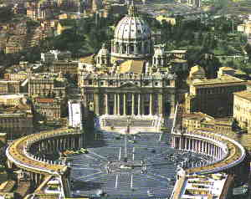As people doubted the Pope’s and the Roman Catholic Church’s teaching, they began protests against the Roman Catholic Church. These people, like Luther, became “Protestants,” that is, “people in protest.” Roman Catholic leaders ridiculed those who followed Luther’s teachings by calling them, “Lutherans.”
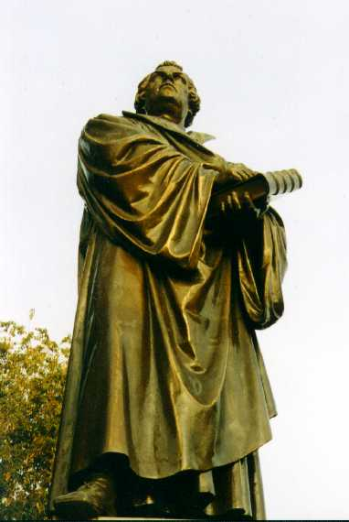
When Luther died on February 18, 1546, he was know as the leader of one of the greatest religious movements in his millennium. As a result of the Lutheran Reformation, people read the Bible and studied it for themselves. Luther’s Small Catechism was, perhaps, Luther’s most important book to help people understand the Bible…and God’s love for them. Still in use today, Luther’s Small Catechism has been in use longer than any other catechism in history.
In addition to his many writings including the Large Catechism and Small Catechisms, Luther wrote many hymns, liturgies and other
resources to share his message: Only Scripture, Only Grace,
Only Faith.
Martin Luther
For Reflection:

1) What was one of the reasons that Luther’s Reformation changed the world?

2) Could a Reformation, like that in Luther’s day, happen today? How?

3) What do you think is most remarkable about Martin Luther?

Study Guide: “Martin Luther”
Part I: True Or False. Martin Luther. Place a “T” (True) or “F” (False) before each question below.

___ 1. Martin Luther was an African-American pastor who believed African-Americans
should have equal rights.

___ 2. Luther’s father was a coal miner and his mother was a Catholic nun.

___ 3. When Luther was kidnapped, he was tortured, mistreated and left for dead.

___ 4. “Protestants” are people who protested against the Catholic Church.

___ 5. The Ninety-Five Theses are simply ninety-five statements by Luther praising
the Pope for the good job he was doing.

___ 6. Luther’s Small Catechism is the oldest catechism still in use today.

___ 7. The three main points of the reformation are “Do it,” “Do it right” and
“Do it now!”

___ 8. Frederick the Elector was a German prince who was a friend of Luther.

___ 9. Luther went into prison for nailing the Ninety-Five Theses on the door of
the church.

___ 10. Luther’s greatest problem with Catholics was that they taught that people
were saved only by Jesus’ death on the cross for them.

